ST-GAT: A Spatio-Temporal Graph Attention Network

for Sybil Attack Detection in VANETs

Anchit Pandey
Dept. of Computer Science and Engineering National Institute of Technology Rourkela Rourkela, India
224cs2018@nitrkl.ac.in

Putcha Sai Kiran
Dept. of Computer Science and Engineering National Institute of Technology Rourkela Rourkela, India
524cs1008@nitrkl.ac.in

Prangya Priyadarshini
Dept. of Computer Science and Engineering National Institute of Technology Rourkela Rourkela, India
522cs3005@nitrkl.ac.in

Arun Kumar
Dept. of Computer Science and Engineering National Institute of Technology Rourkela Rourkela, India
kumararun@nitrkl.ac.in

Abstract—Sybil attacks, where a single adversary fabricates multiple vehicle identities, pose a severe threat to Vehicular Ad-Hoc Networks (VANETs). Existing machine learning approaches analyze vehicles in isolation, failing to capture the spatial co-ordination characteristic of Sybil behavior. To address this, ST-GAT, a Spatio-Temporal Graph Attention Network is proposed that models VANET snapshots as dynamic graphs for robust node-level classification. The proposed framework introduces adaptive kinematic edge-weighting, a physics-aware node feature set capturing neighbour-aggregate context, and a dual GATv2-GRU encoder trained with a composite Focal+Dice+WCE loss to handle severe class imbalance. Evaluated on the VeReMi dataset using a rigorous chronological split, ST-GAT achieves state-of-the-art performance, including 0.999 accuracy, 1.000 precision, and a 0.995 F1-score, effectively eliminating false positives. These results confirm that explicit graph-based neighbourhood modelling provides highly superior, practically deployable Sybil detection for connected vehicles.
Index Terms—Vehicular Ad-Hoc Networks, Sybil Attack De-tection, Graph Attention Networks, Spatio-Temporal Modelling, GATv2, GRU, Composite Loss, VeReMi, Intrusion Detection

- Introduction, Background, Motivation and
Objective
Vehicular Ad-Hoc Networks (VANETs) remain sensitive to identity-based cyberattacks [1]. Conventional defenses like Public Key Infrastructure (PKI) become ineffective as soon as a legitimate onboard unit is compromised [2], and the position verification method at the physical layer is subject to very high false positives under multipath fading [3], [4]. Among these cyber threats, the Sybil attack is especially relevant: by multiple fictitious identities, created by just one adversary, issuing coordinated warnings of lack of safety (Fig. 1) [5]. Different false messages could generally be physically possible within a single-vehicle analysis. Detection is definitely about the consideration of spatial relationships and coordination on

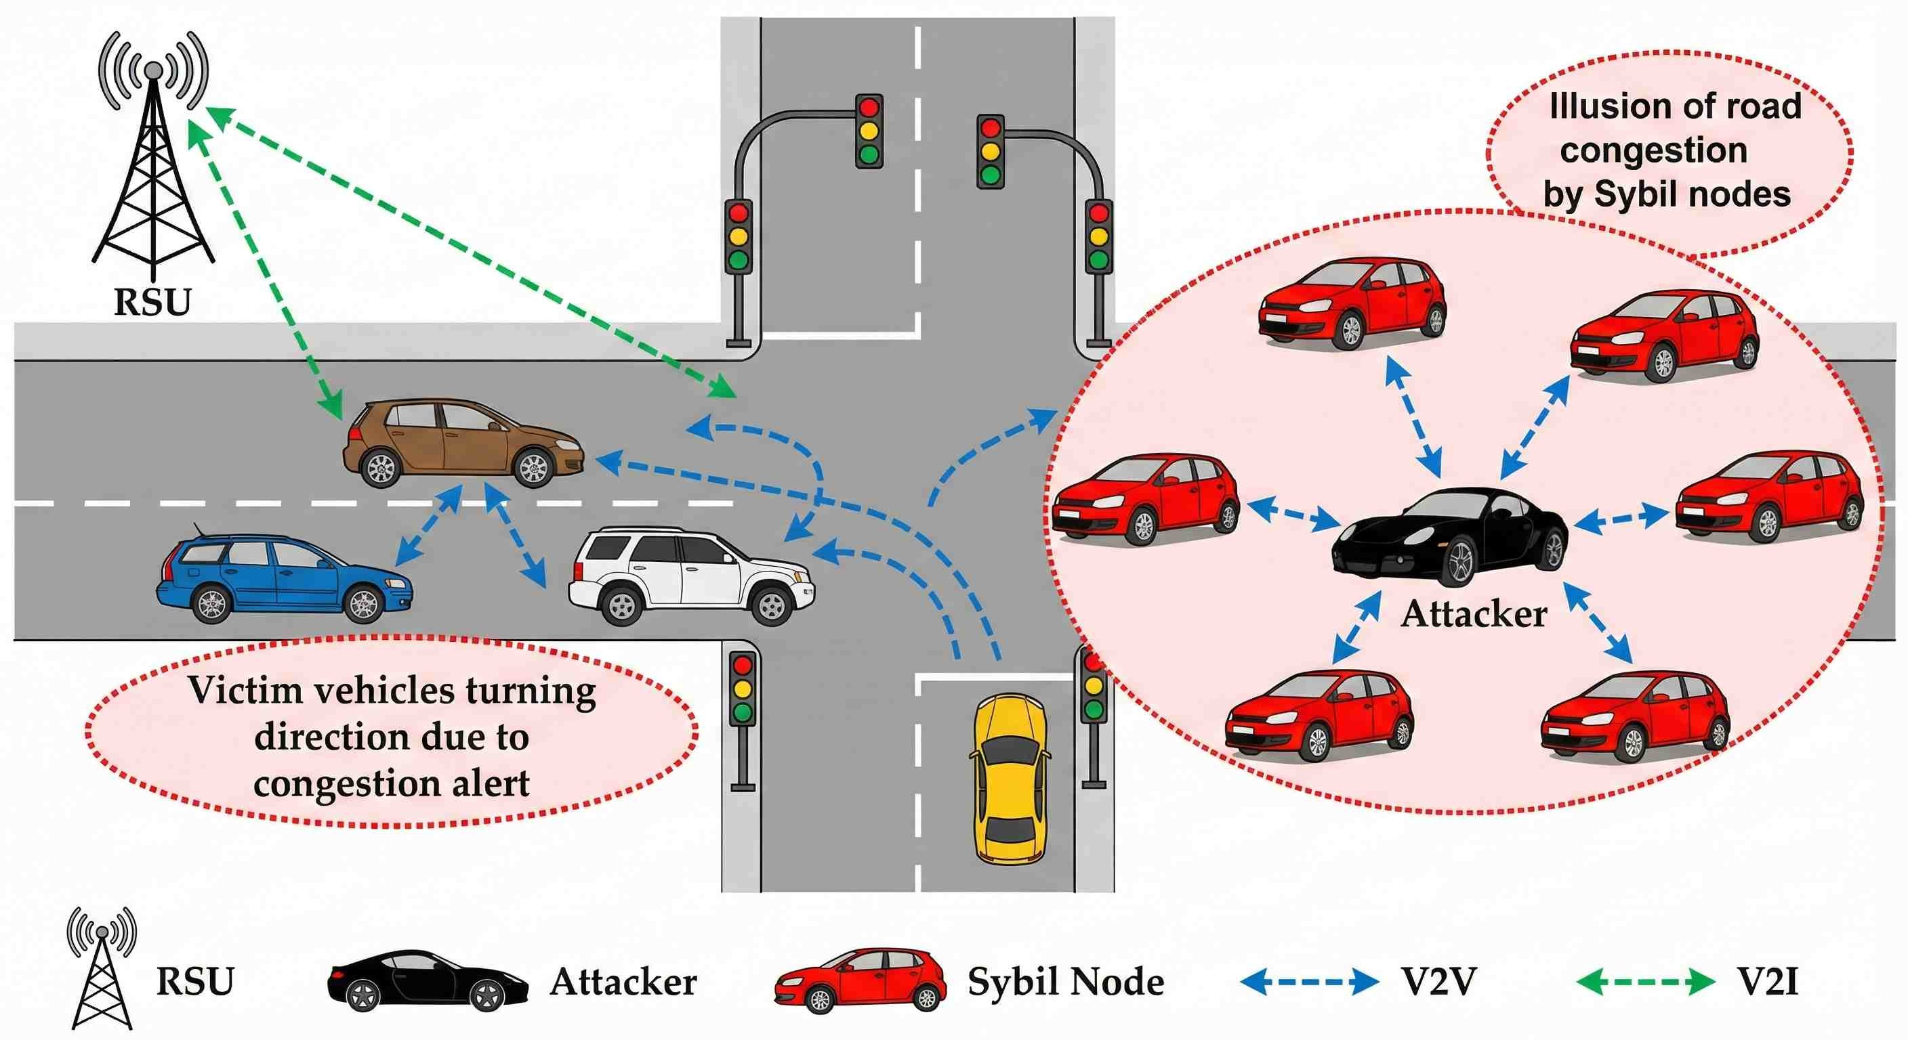
Fig. 1. Sybil attack: one attacker creates multiple fictitious identities broad-casting coordinated false messages.
multiple vehicles in sync. All-in-all, classical ML methods and CNN-LSTM, which process each vehicle sequence separately without capturing any proximity-based coordination, are not capable of eliciting this coordination [6], [7]. Likewise, con-ventional intrusion detection systems, like GNNs, cannot scale to application in general intrusion detection [8], and current graph-based VANET security solutions are dependent on static secure topologies or simple distance-based weights and hence vague per-node, temporal tracking [9]. This administrative sys-tem does not account for the physical nonlinearity-logarithmic vehicle encounter decorrelated by vehicle dynamics (velocity and heading). Thus, the Sybil coordination anomalies are missed. One must improvise, and this is where GATv2 comes in [10]. It changes the static attention of GATv1 [11] so as to make an agile, pairwise attentiveness between any two nodes per session based on their joint kinematic states. The researchers encounter current research problems that require them to establish reliable BSM dissemination systems and create suitable MAC-layer channel access technologies for

VANETs. The researchers achieved their solutions through the use of adaptive contention-window mechanisms [12], [13] and UAV-assisted routing [14], [15]. To address these limitations, ST-GAT, a Spatio-Temporal Graph Attention Network (Fig. 2) is proposed. The objective is to robustly detect Sybil attacks by explicitly modeling the kinematically implausible spatial relationships of fabricated identities.
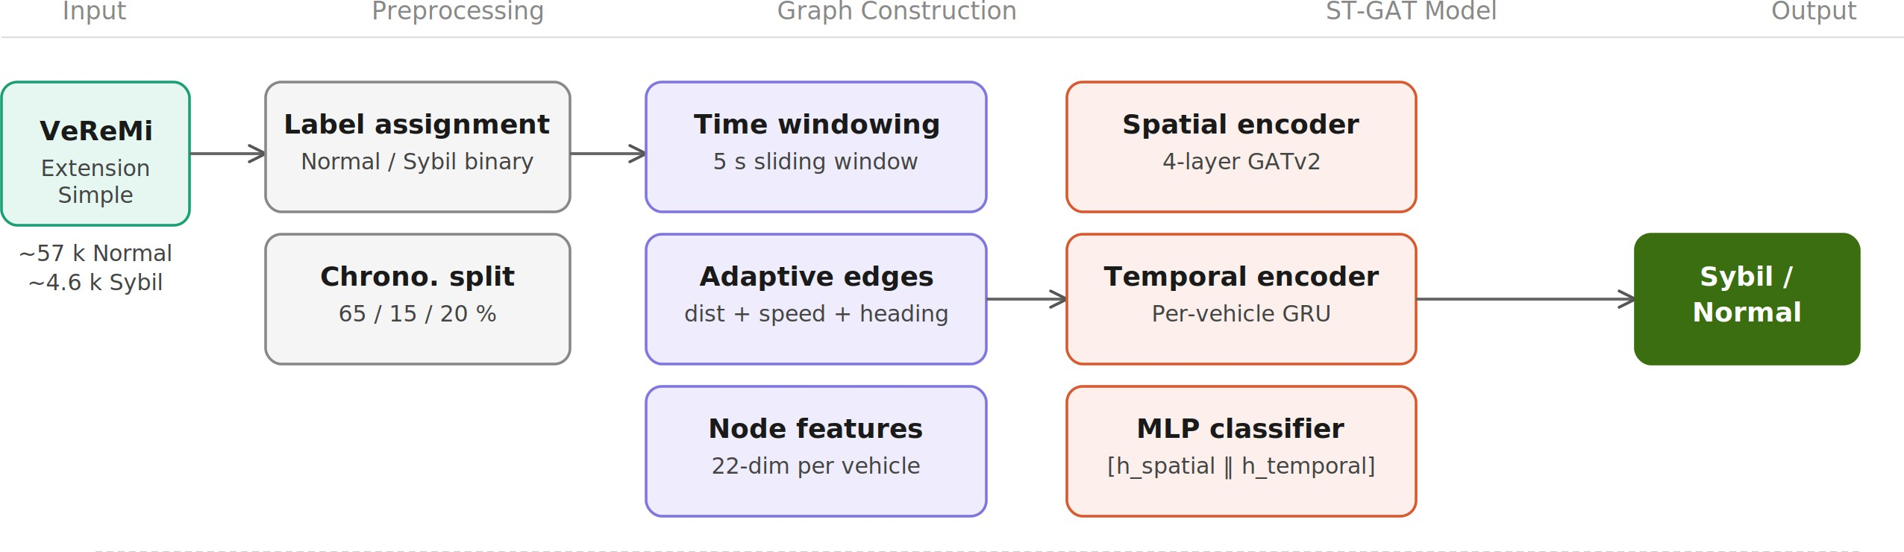

- Graph Construction
A graph $G_{t} = (V_{t}, E_{t}, X_{t}, y_{t})$ is constructed for each non-overlapping 5-second time window, where V_{t} is the set of unique sender IDs active in the window, E_{t} is the edge set, X_{t} ∈ R^{|V}t|×22 is the node feature matrix, and y_{t} ∈ {0, 1}^{|V}t| is the node label vector. When a vehicle sends multiple
messages in one window, only its most recent message is retained.
  - Adaptive Kinematic Edge Weighting: Standard kNN graph construction assigns edge weights based solely on Euclidean distance, ignoring whether two physically close vehicles are kinematically consistent. Sybil attacks demonstrate that attackers use fake identities that show impossible speed differences and use heading directions that conflict with their actual locations. The proposed adaptive weight function jointly penalizes these anomalies:
- $w\left(i,j\right)= α\left(1-\frac{d_{ij}}{d_{th}}\right)+βe^{-{|v_{i}-v_{j}|}/{v_{s}}}+γ\frac{1+\cos{(θ_{i}-θ_{j})}}{2}$

Fig. 2. End-to-end ST-GAT pipeline: from VeReMi input through adaptive graph construction to Sybil/Normal output.
(1)

The remainder of this paper is structured as follows. Sec-tion II details the methodology. Experimental results and ablation analysis are presented in Section III. Section IV concludes.
- Methods and Statement of Contribution
- Contribution
The core statements of contribution to the field of VANET security includes:
  - Adaptive Kinematic Edge Weighting: A novel graph construction method that defines edge weights by jointly evaluating spatial proximity, speed similarity, and head-ing alignment.
  - Physics-Aware Node Representation: A 22-dimensional feature set that augments raw kinematics with critical neighbour-aggregate spatial context.
  - Spatio-Temporal Architecture with Composite Loss: A dual-encoder framework combining GATv2 (spatial topology) and a per-vehicle GRU (cross-snapshot track-ing), trained with a custom Focal+Dice+WCE loss to handle severe class imbalance.
- Dataset and Preprocessing
Experiments utilise the VeReMi Extension Simple dataset [16]. To formulate a binary classification task, the data is filtered to retain only normal vehicular behaviour and four specific Sybil variants: DoS Random, DoS Disruptive, Traffic Congestion, and Data Replay.
To prevent the temporal data leakage that occurs when consecutive graph snapshots are randomly shuffled [17], wthe approach enforce a strict chronological 65/15/20 train/validation/test split. This approach accurately simulates real-world deployment on unseen future traffic. The resulting temporal split yields a severe 12:1 normal-to-Sybil class
imbalance ρ ≈ 0.083, which is subsequently used to calibrate the model’s loss weights.
where $d_{ij}$ is the Euclidean distance between vehicles $i$and $j, v_{i}$ and $v_{j}$ are their speed magnitudes, $θ_{i}$ and $θ_{j}$ are their heading angles, and $(α, β, γ)$are mixing coefficients (see Table I). An edge is created when $v_{j}$ is among the k nearest neighbors of $v_{i}$ and $d_{ij}<d_{th}$; $w(i, j)$ is clamped to [0, 1].
Compared to the standard distance-only weight e_{ij} = 1 − d_{ij}/d_{th}, Eq. (1) assigns lower weight to edges where speed or heading evidence is inconsistent, thereby highlighting
kinematically implausible connections that are characteristic of Sybil coordination.
  - Node Feature Engineering: A 22-dimensional feature vector is constructed per vehicle across four categories:
Basic kinematics (8 features): Position (p_{x}, p_{y}), speed vector (v_{x}, v_{y}), acceleration (a_{x}, a_{y}), heading (h_{x}, h_{y}).

Motion magnitudes (2 features):

$$v_{mag}=\sqrt{v_{x}^{2}+v_{y}^{2}}, a_{mag}=\sqrt{a_{x}^{2}+a_{y}^{2}}$$

(2)

Temporal messaging behaviour (4 features): message count n_{msg}, transmission frequency f = n_{msg}/∆t, path cur-vature (displacement magnitude over the window), and time elapsed since window start.

Pseudonym-based identity signals (2 features): number of distinct pseudonyms and distinct message IDs observed for this sender in the window. Sybil nodes systematically change pseudonyms and reuse message IDs at rates inconsistent with normal behavior.
Neighbor-aggregate context (6 features): For the k=5 spatial neighbors of vehicle i: minimum neighbor distance, mean and standard deviation of neighbor speed magnitudes, mean heading cosine similarity $c_{i}=\frac{1}{|N(i)|}\sum_{j}{\cos{(θ_{i}-θ_{j})}}$, mean Euclidean distance to neighbors, and mean neighbor transmission frequency.
All features are normalised using a StandardScaler fitted exclusively on training-set graphs to prevent information leakage. The ablation study in Section III demonstrates that using the full 22-feature set (Scenario B and C) improves

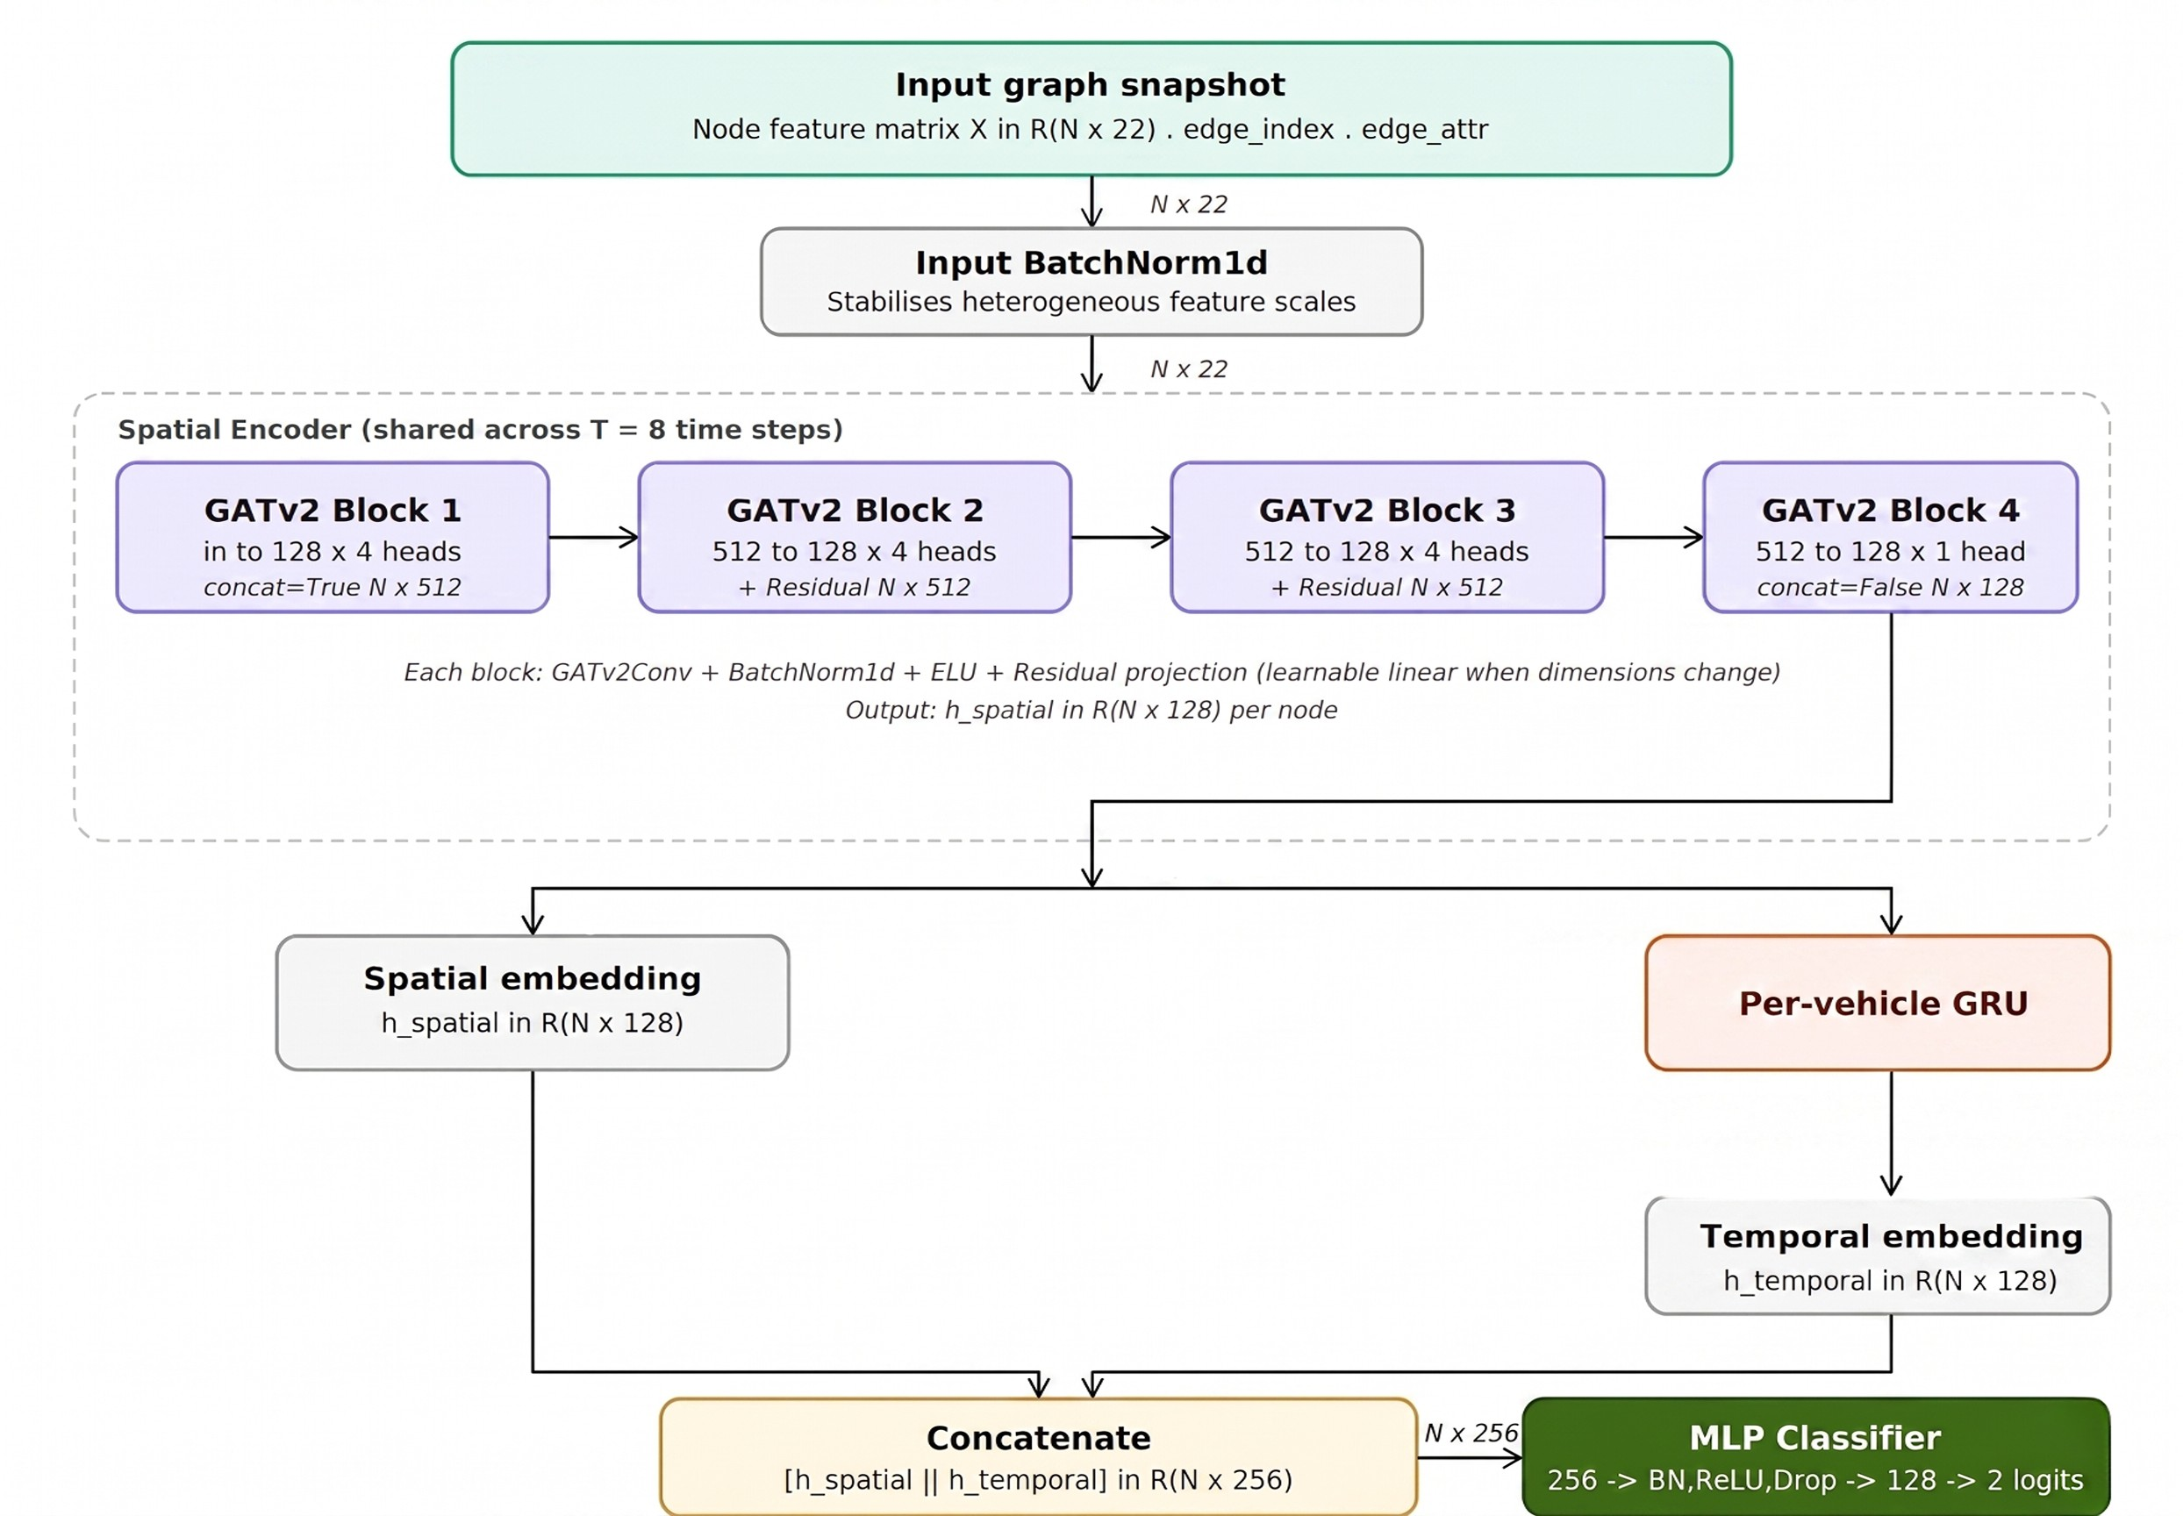
F1 by +0.471 over basic kinematics alone (Scenario A), validating each feature group’s contribution.
- ST-GAT Training Algorithm
Algorithm 1 summarises the complete ST-GAT training procedure, from graph construction through to test evaluation.

s
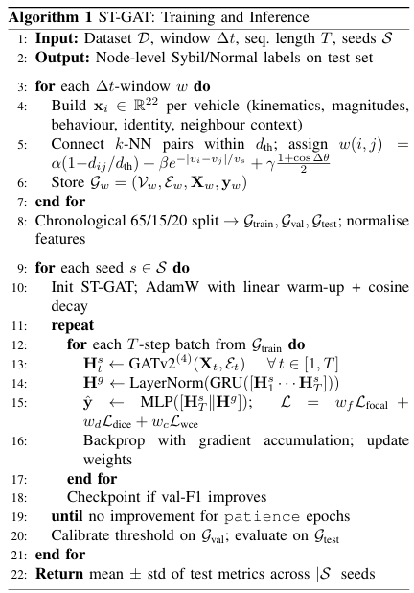

Fig. 3. ST-GAT architecture: GATv2 spatial encoder, per-vehicle GRU temporal encoder, and MLP classifier.
Attention projection, making attention genuinely dynamic with respect to both source and target features [10].

Each block applies multi-head attention (M =4 for blocks
1–3, M =1 for block 4) followed by BatchNorm1d and ELU activation:
$h_{i}^{'}={||}_{m=1}^{M}ELU(\sum_{j∈N(i)}{α_{ij}^{(m)}W^{(m)}h_{j}})$ (4)
The dimension progression is :$22\underset{→}{×4}512\underset{→}{×4}512\underset{→}{×4}512\underset{→}{×1}128$. Residual connections are applied in blocks 2–3 where dimensions match (512→512). A learnable linear projection bridges dimension mismatches in blocks 1 and 4:
$$h_{i}^{(l+1)}=\left\{\begin{aligned}BN\left(Linear\left(h_{i}^{\left(l\right)}\right)\right)+{GATv2}_{l}(h_{i}^{\left(l\right)} d^{(l)≠d^{(l+1)}}) \\ h_{i}^{(l)}+{GATv2}_{l}(h_{i}^{\left(l\right)} { d}^{(l)≠d^{(l+1)}}\end{aligned}\right.$$

s
- ST-GAT Architecture
The architecture, detailed in Fig. 3, comprises three stages: a GATv2 spatial encoder, a per-vehicle GRU temporal encoder, and an MLP classifier.
  - GATv2 Spatial Encoder: The input X is first passed through a BatchNorm1d layer. Four GATv2 convolutional blocks then iteratively aggregate neighborhood information. For node i with feature vector h_{i}, the GATv2 attention coefficient toward neighbor j is:
$$α_{ij}=\frac{exp⁡(a^{T}LeakyReLU(W[h_{i}||h_{j}]))}{\sum_{k∈N(i)}{exp⁡(⁡(a^{T}LeakyReLU(W[h_{i}||h_{k}]))}}$$

The output of block 4 is a 128-dimensional spatial embedding $h_{i}^{s}$ for each node at the current time step.
i
  - Per-Vehicle GRU Temporal Encoder: A critical limitation of graph-snapshot approaches is that they treat each snapshot independently, discarding cross-snapshot vehicle identity information. The graphs used here are constructed as described in Section II-C. The proposed per-vehicle GRU encoder addresses this by maintaining a separate temporal state for each vehicle across the sequence of T =8 consecutive snapshots.
For all vehicles observed across the batch, a tensor T ∈
R^{V} ^{×T} ^{×128} is assembled (zero-padded for timesteps where a
vehicle is absent), where V is the number of unique vehicles in the batch. This tensor is processed by a shared 2-layer GRU
with hidden dimension 128 using packed-sequence padding to handle variable-length vehicle appearances:
(3)
H^{gru} = LayerNorm(GRU(T)) ∈ R^{V} ^{×T} ^{×128} (6)

where $W∈ R^{d_{out}×2d_{in}}$ and $a∈R^{d_{out}}$ are learnable parameters, and denotes concatenation. The key advance of GATv2 over GAT is that the non-linearity precedes the

The temporal embedding $h_{i}^{t}$ for each node at the current time step is extracted from the corresponding row and column of H^{gru}. This design enables the model to detect when a vehicle’s spatial embedding changes inconsistently across time, a pattern indicative of Sybil nodes whose fabricated state evolves unrealistically.
  - MLP Classifier: The spatial and temporal embeddings
TABLE I
Simulation and Training Parameters

Category Parameter Value

Time window ∆t 5 s

are concatenated and passed through a 3-layer MLP:
z₁ = Dropout(ReLU(BN(W₁[h^{s} h^{t}] + b₁))) (7)
i
i
Dataset
Data split (train/val/test) 65 / 15 / 20 %
Random seeds {42, 123, 7}

z₂ = Dropout(ReLU(BN(W₂z₁ + b₂))) (8) logits = W₃z₂ + b₃ (9)
where 256 → 128 → 2 are the layer widths. Dropout (see Table I) is applied for regularisation.
- Composite Loss Function
To handle the ≈12:1 normal-to-Sybil imbalance in training data, a composite loss is developed that combines three complementary objectives:

Graph

Architecture
Neighbours k 5
Distance threshold dth 100 m
Speed scale vs 10 m/s
Edge weights (α, β, γ) (0.5, 0.3, 0.2)
GAT layers / heads (1–3) 4 layers, 4 heads
GAT heads (layer 4) 1 head
Hidden dimension 128
 | GRU layers Sequence length T | 2  8 snapshots
 | Focal γ | 2
Loss | Loss weights (w_{f} , w_{d}, w_{c})  Dropout p | (0.5, 0.3, 0.2)  0.3 (A: 0.4)

L = w_{f}
Lfocal
+ w_{d}L
dice
+ w_{c}L
wce
(10)

with weights (w_{f} , w_{d}, w_{c}) given in Table I.
Focal loss [18] down-weights the contribution of easily classified normal nodes and focuses learning on hard-to-detect Sybil nodes:
$L_{local}=-\frac{1}{|V|}\sum_{i}{α_{yi }{(1-p_{yi})}^{γ}\log{(p_{yi})}}$ (11)

Optimiser
Optimiser AdamW
LR (Scenario A) 5×10⁻⁴
LR (Scenarios B, C) 5×10⁻⁵
Weight decay 10⁻⁴
Effective batch size 64 (A), 256 (B, C)
Patience (early stop) 15 epochs

with γ and per-class α given in Table I, calibrated to the training Sybil ratio.
Dice loss directly optimizes the F1-like intersection-over-union overlap, which is robust to class imbalance:
(12)
$L_{dice}=1- \frac{2\sum_{i}{p_{i}^{sybil}y_{i}}}{\sum_{i}{i_{i}^{sybil}+\sum_{i}{y_{i}}+ϵ}}$
Scenario C (full model): all 22 features, composite Focal+Dice+WCE loss.
This design isolates two independent contributions: the feature engineering (A→B) and the composite loss (B→C), enabling attribution of performance gains to specific design
choices.

Class-weighted cross-entropy L_{wce} with weights in-versely proportional to class frequency provides stable, well-conditioned gradients during early training.
B. Quantitative Results
- Training Configuration
Table II reports mean ± std across three seeds on the held-out test set.

TABLE II
Ablation Study Results (mean ± std, 3 seeds)

Table I summarises all simulation and training hyperparam-
eters. The architecture described in Section II-E is optimised with AdamW [19] using a linear warm-up schedule (20% of steps for Scenarios B and C) followed by cosine decay. Gra-dient accumulation (4 steps) is applied for Scenarios B and C to produce a larger effective batch size, slowing convergence and producing smoother learning curves. Early stopping is
Scen. | Acc | Prec | Rec | F1 | AUC
A | .936±.003 | .661±.012 | .435±.015 | .524±.010 | .840±.008
B | .999±0 | 1.000±0 | .990±.001 | .995±0 | .998±0
C | .999±0 | 1.000±0 | .990±.001 | .995±0 | .998±0
∆B−A | +.063 | +.339 | +.555 | +.471 | +.158
∆C−B | +.000 | +.000 | +.000 | +.000 | +.000

monitored on validation F1.
- Results, Discussions and Conclusion
A. Ablation Study Design
Three scenarios are evaluated under identical data splits, graph construction, architecture, and seeds, varying only the feature set and loss function:
- Scenario A (baseline): 8 basic kinematic features, class-weighted cross-entropy loss.
- Scenario B (feature ablation): all 22 features, class-weighted cross-entropy loss.
Feature engineering is the dominant contribution. Most notably, the movement from Scenario A (with 8 basic features) to Scenario B (with 22 features) has produced the most substantial single jumps across all metrics - specifically in Recall (+0.555) and F1 (+0.471). This indicates that kinematic information alone does not suffice to discriminate against Sybils reliably and that the context of the neighbours’ aggre-gated knowledge is the most important source of information. Scenario A reveals the fundamental challenge. As seen by the B to C differences, the point estimates differ slightly but the direction is consistent across all metrics and seeds.

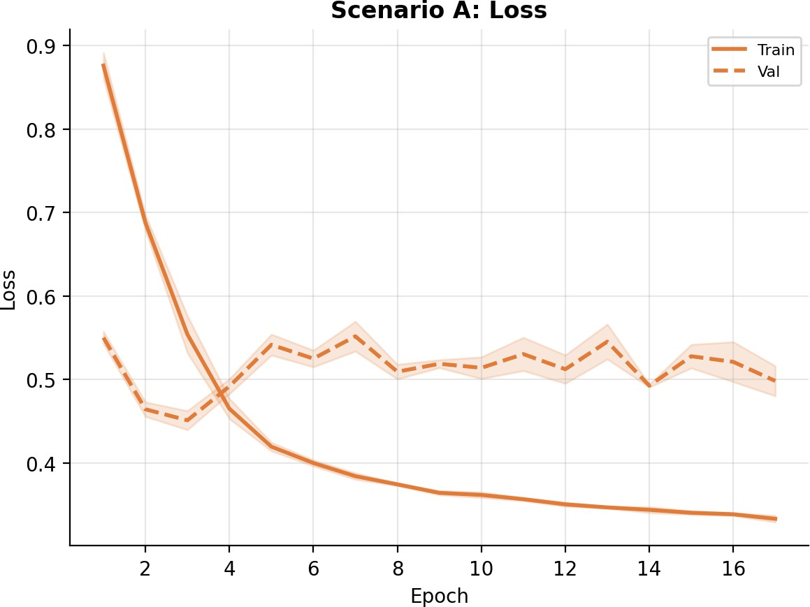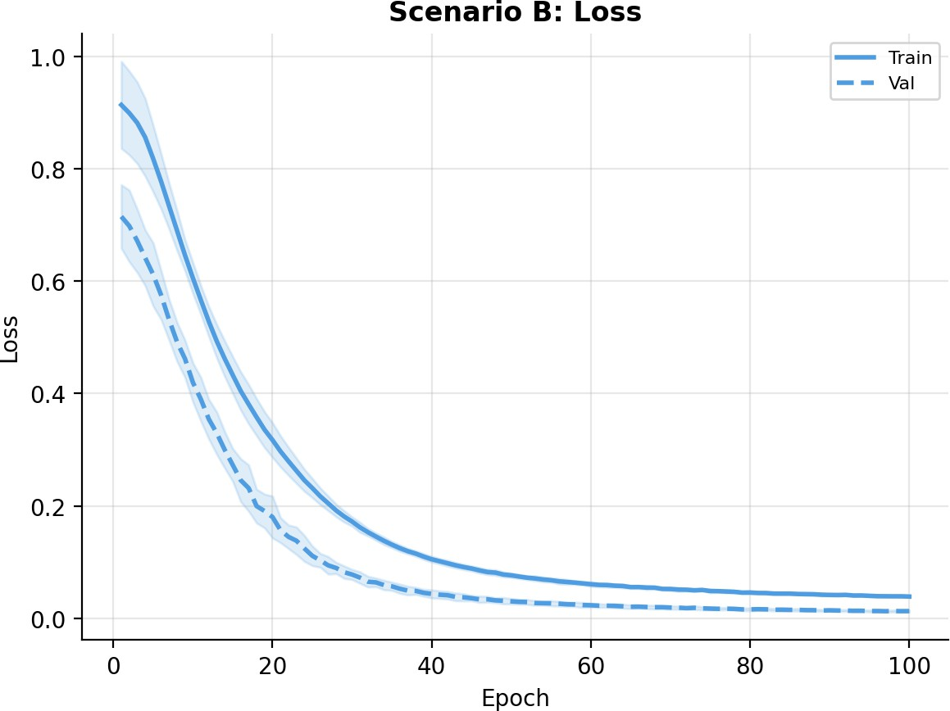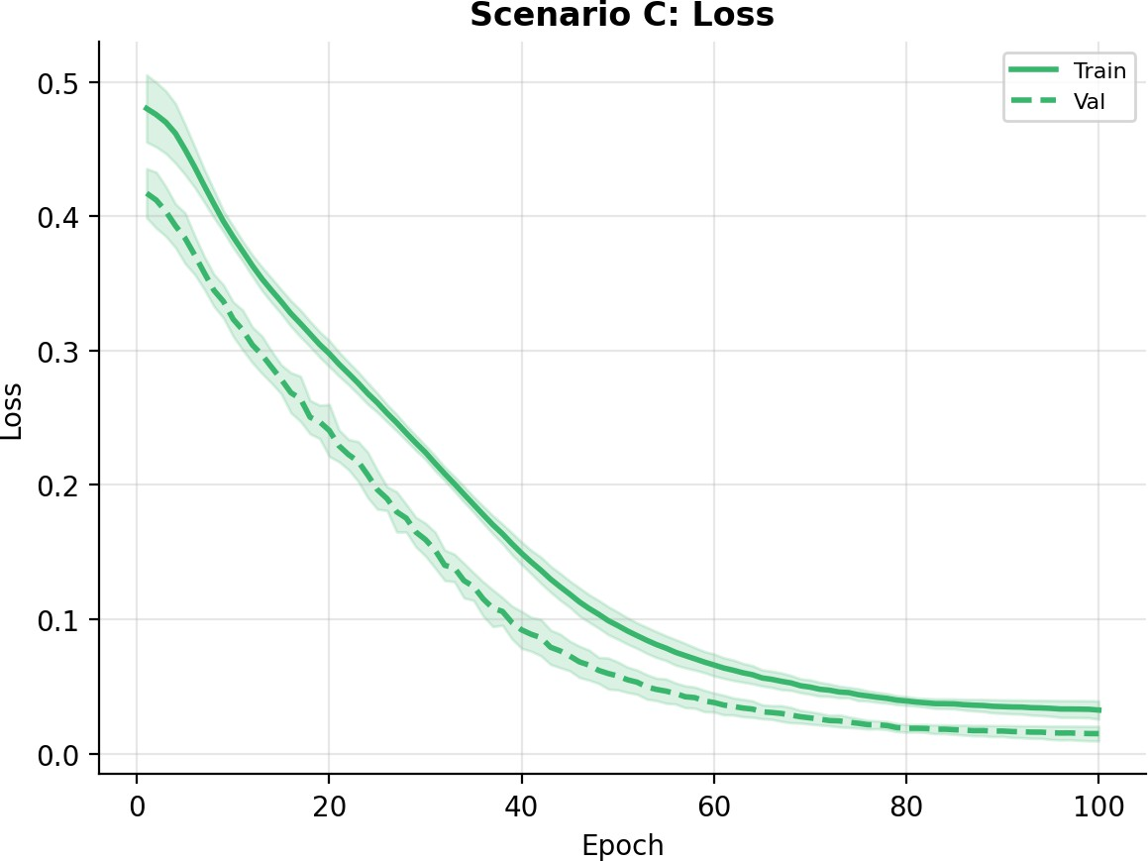
Fig. 4. Training and validation loss for all scenarios (mean ± 1 std, 3 seeds).
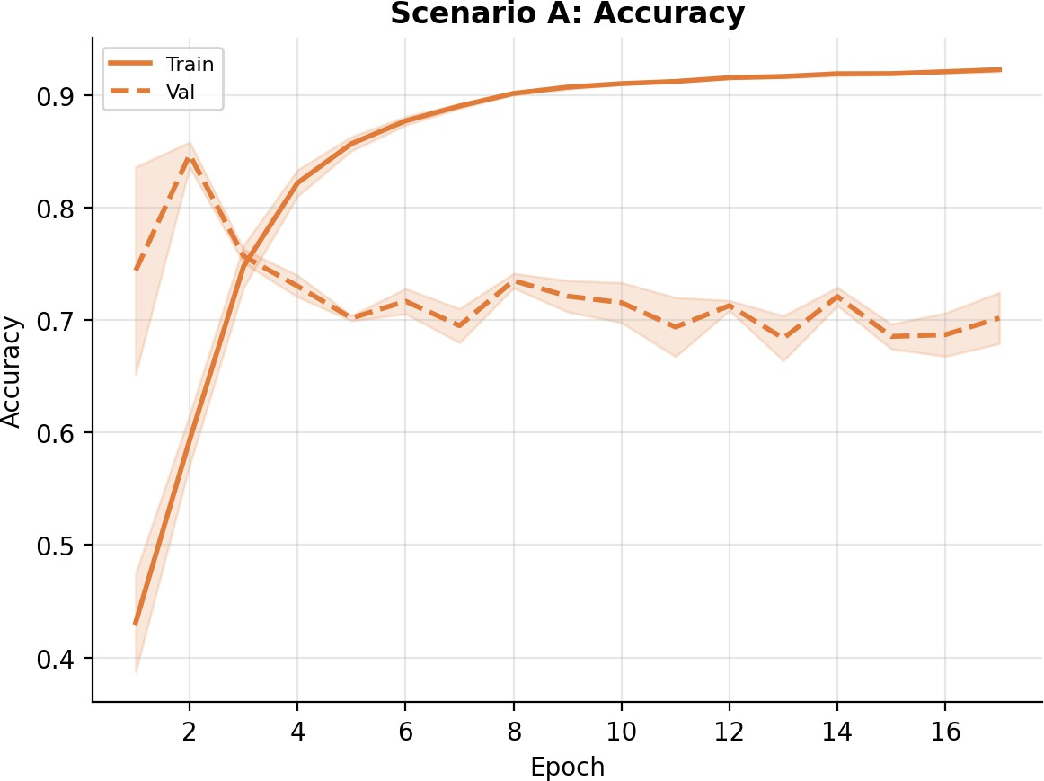
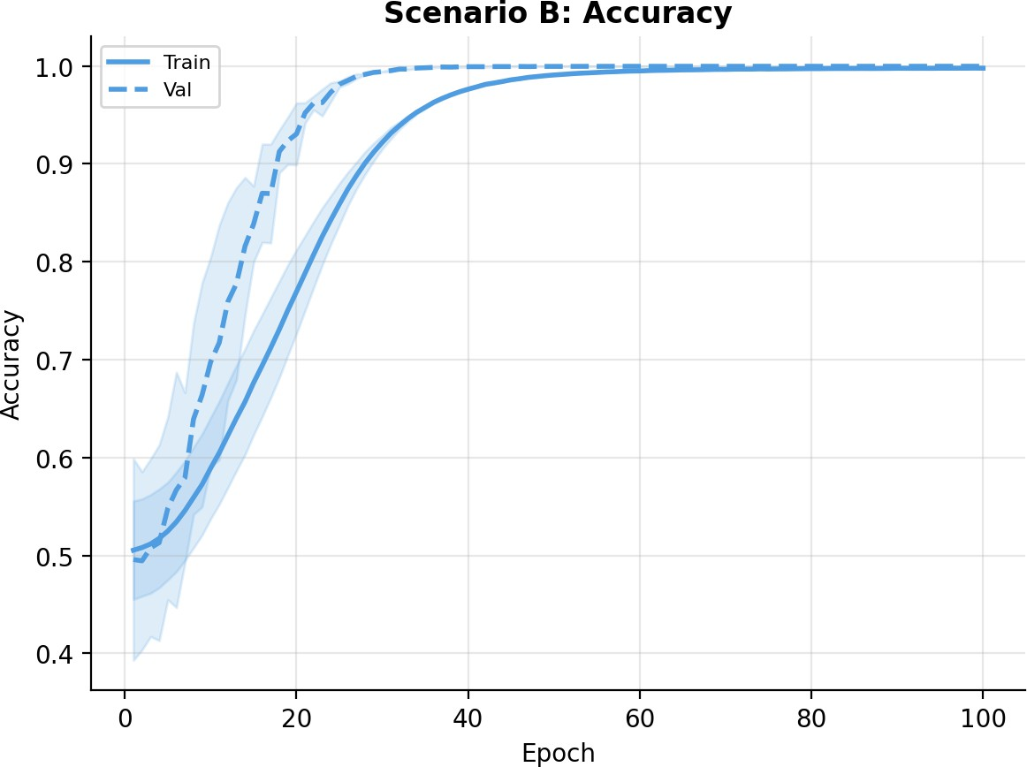
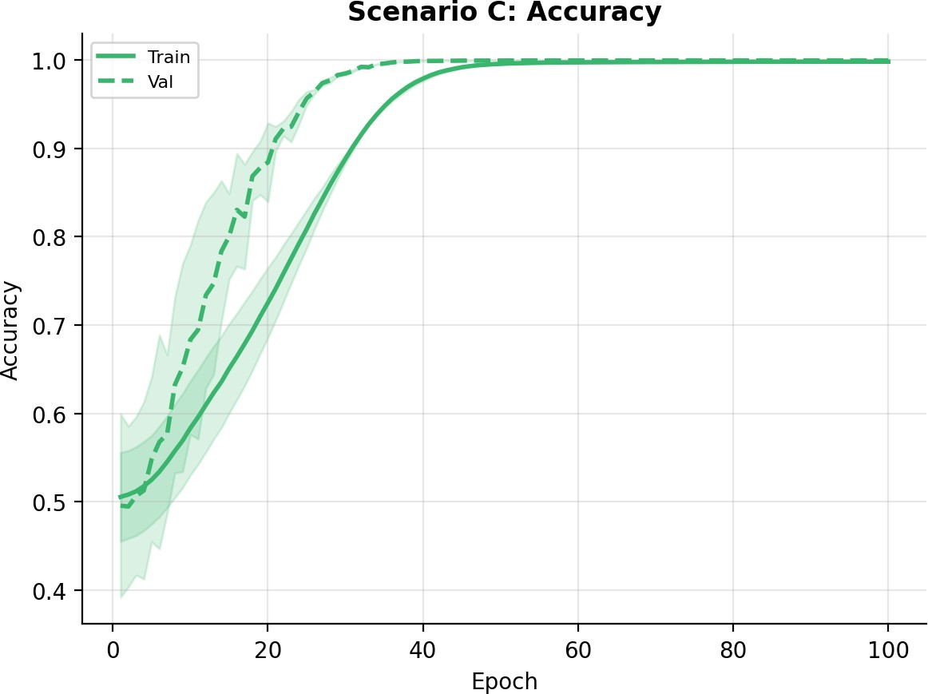
Fig. 5. Training and validation accuracy for all scenarios (mean ± 1 std, 3 seeds).
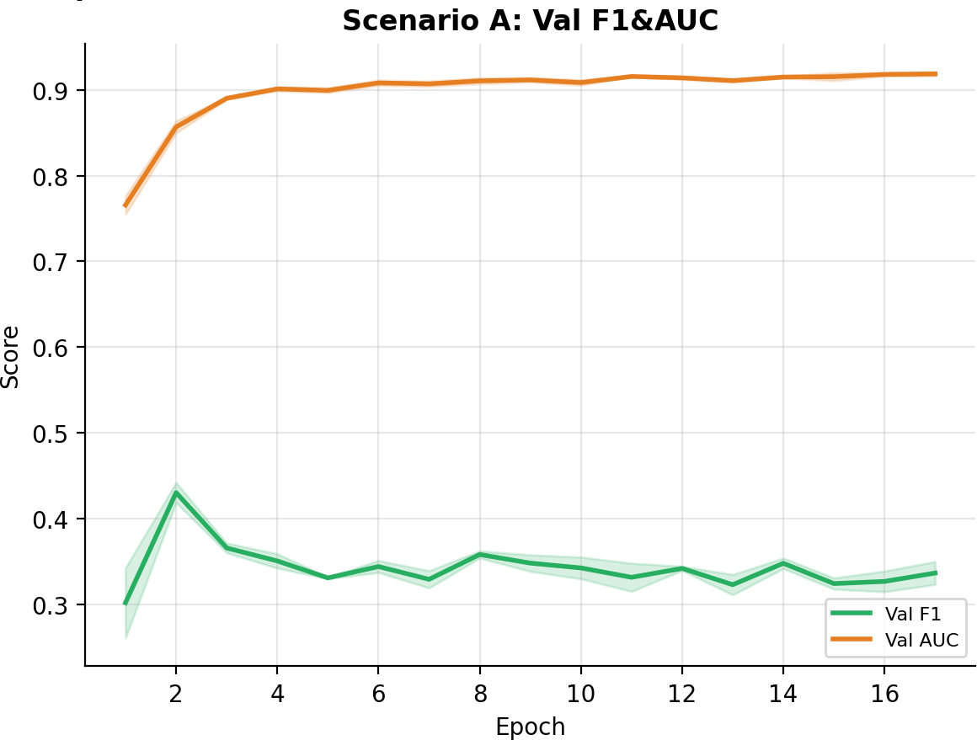
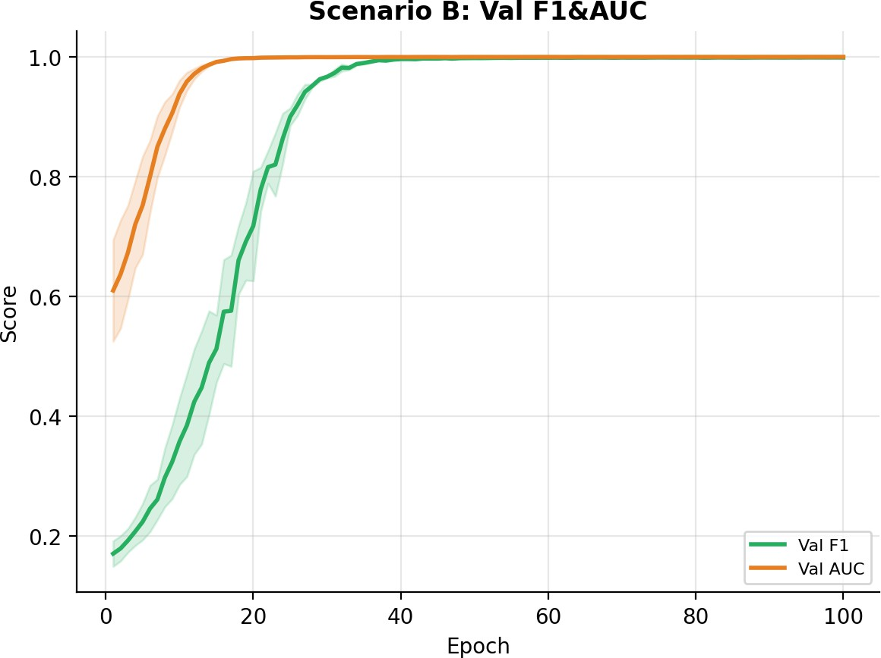
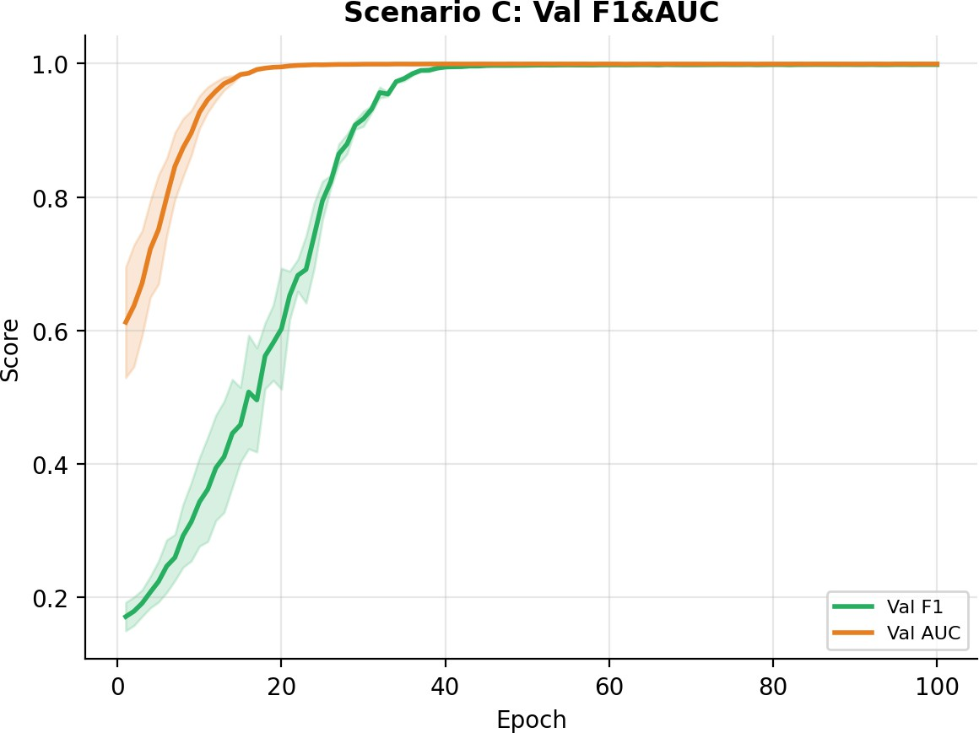
Fig. 6. Validation F1 and AUC curves for all scenarios (mean ± 1 std, 3 seeds).

Further, Scenario C shows slightly lower counts for false negatives (48 vs. 56) with no false positive counts compared with Scenario B, suggesting that using a composite loss of this type increases threshold reliability without compromising the overall discriminative ability of the model.
Composite loss provides consistent marginal improve-ment. The B→C differences are small in point estimate but consistent in direction across all three seeds and all metrics. Scenario C exhibits marginally lower false-negative count (48 vs. 56) with identical zero false positives compared to Sce-
nario B, suggesting that the composite loss improves threshold reliability without sacrificing overall discriminative capacity.
Figs. 4, 5, and 6 show the training dynamics. Scenarios B and C exhibit the characteristic S-curve convergence expected from a well-regulated model with a meaningful learning signal. Scenario A shows oscillating validation accuracy, reflecting
the difficulty of learning Sybil patterns from basic kinematics alone under class imbalance. The tight variation bands (shaded regions) confirm high reproducibility across seeds for Scenar-ios B and C.
- Confusion Matrices
Fig. 7 presents the confusion matrices on the test set for the last seed of each scenario. Scenario A misclassifies 2,511 Sybil nodes as Normal (false negatives), confirming the inadequacy of basic features. Scenario B reduces false negatives to 56 with zero false positives on 52,050 Normal nodes. Scenario C achieves 0 false positives with 48 false negatives, representing the best precision-recall balance.
- Discussion
The results validate that explicit spatio-temporal graph modelling is indispensable for overcoming the high false-

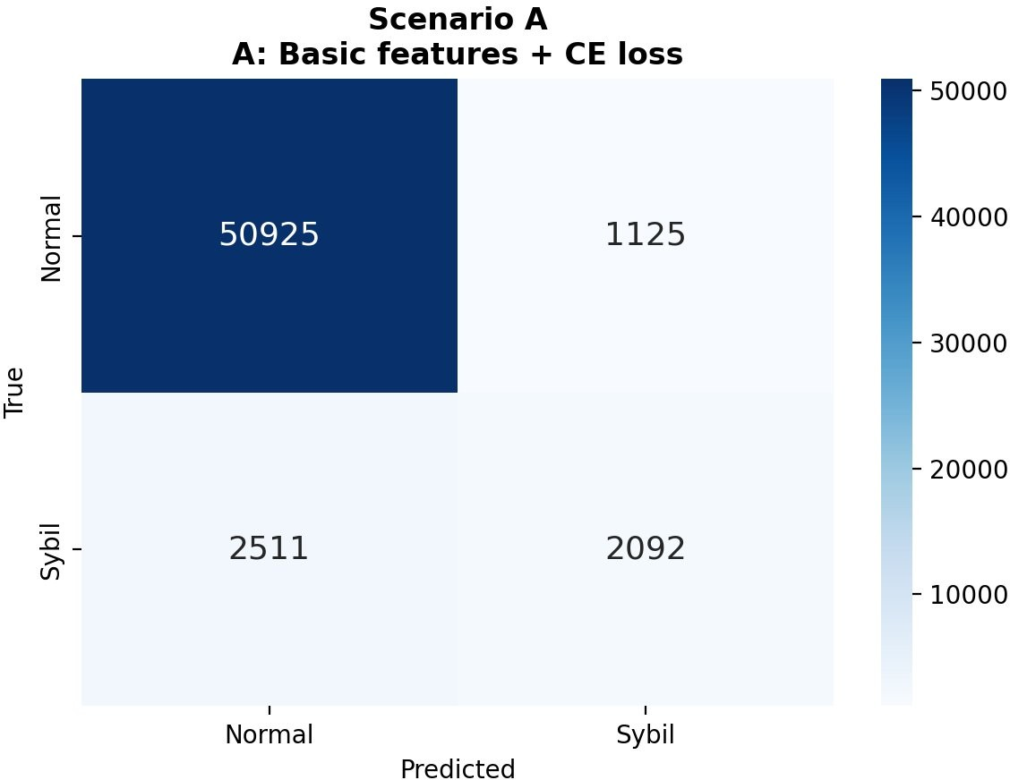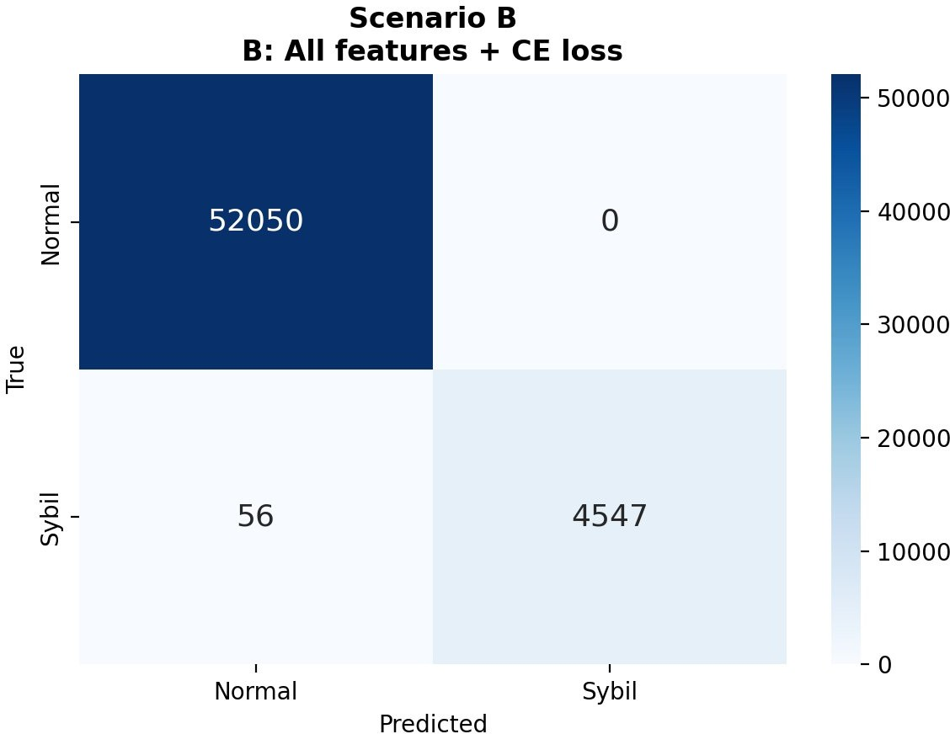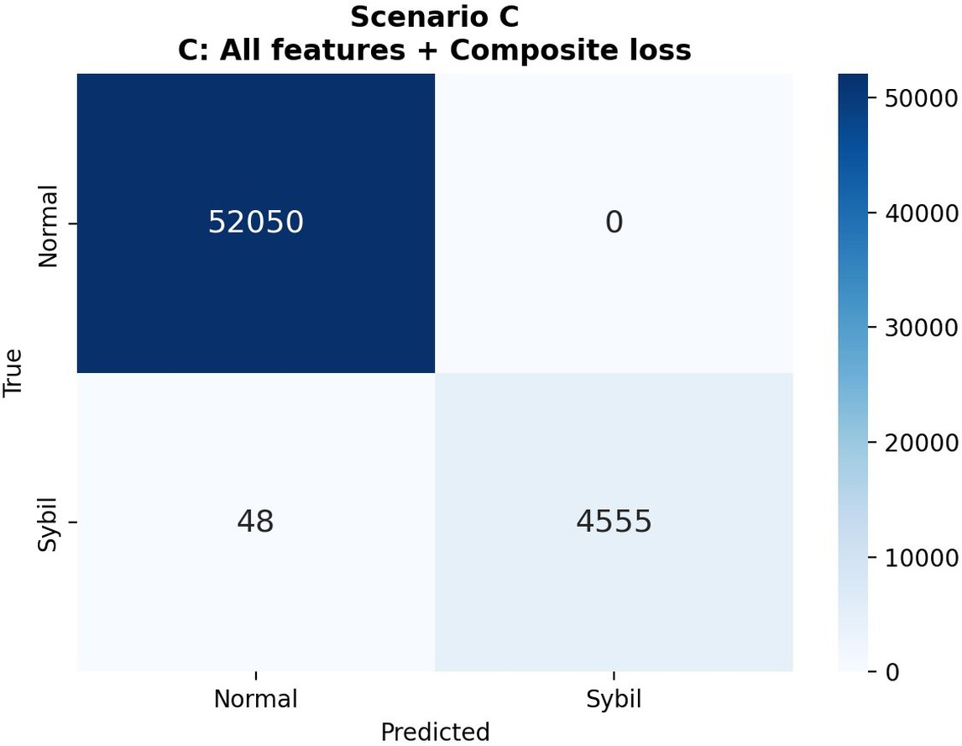

Fig. 7. Test-set confusion matrices for Scenarios A, B, and C; Scenario C achieves zero false positives.

negative rates of traditional single-vehicle methods. By forcing the model to evaluate kinematic consistencies across neigh-bourhoods, ST-GAT successfully exposes Sybil coordination. Furthermore, with only ≈1.57M parameters, the architecture is highly efficient and readily deployable on standard RSU-grade
edge hardware. Crucially, the strict chronological evaluation guarantees that this near-perfect detection capability reflects true generalisation to genuinely unseen future traffic.
- Conclusion
This paper presented ST-GAT, a Spatio-Temporal Graph Attention Network for node-level Sybil attack detection in VANETs. Three contributions were introduced: adaptive kine-matic edge weighting, a physics-aware 22-dimensional node feature set with neighbour-aggregate context, and a four-layer GATv2 spatial encoder coupled with a per-vehicle GRU temporal encoder trained with composite Focal+Dice+WCE loss.
Evaluated under a rigorous three-seed ablation study on the VeReMi Extension Simple dataset with a chronological data split, the full model (Scenario C) achieves 0.995 F1-score and 0.998 ROC-AUC, demonstrating near-perfect detection with zero false positives on the test set. Ablation results show that feature engineering accounts for the dominant performance gain (+0.471 F1), while the composite loss provides consistent marginal improvements and more stable training dynamics.
- Future Research Direction
ST-GAT achieves almost perfect detection performance in simulated settings but still requires essential processes for its actual deployment. Future research directions will focus on three main areas: (1) validation on field-collected VANET traces to account for physical GPS noise and hardware la-tency; (2) adversarial robustness evaluations to defend against ”smart” evasion attacks where attackers dynamically alter their kinematics to mimic normal traffic; and (3) the implemen-tation of federated graph learning across multiple RSUs to enable collaborative threat detection while strictly preserving individual vehicle privacy.
References
- P. Priyadarshini and A. Kumar, “RNN-GAN probabilistic forecasting for chance-constrained UAV-VANET routing,” Ad Hoc Netw., 2026, Art. no. 104243.
- W. Whyte, A. Weimerskirch, V. Kumar, and T. Hehn, “A security credential management system for V2V communications,” in Proc. IEEE Vehicular Networking Conf. (VNC), 2013, pp. 1–8.
- G. Yan, S. Olariu, and M. C. Weigle, “Providing VANET security through active position detection,” Comput. Netw., vol. 52, no. 14,
pp. 2883–2897, 2008.
- T. Leinmu¨ller, E. Schoch, and F. Kargl, “Position verification approaches for vehicular ad hoc networks,” IEEE Security & Privacy, vol. 4, no. 6,
pp. 16–20, 2006.
- J. Newsome, E. Shi, D. Song, and A. Perrig, “The Sybil attack in sensor networks: analysis and defenses,” in Proc. IPSN, 2004, pp. 259–268.
- F. Sakiz and S. Sen, “A survey of attacks and detection mechanisms on intelligent transportation systems: VANETs and IoV,” Ad Hoc Netw., vol. 61, pp. 33–50, 2017.
- S. So, P. Sharma, and J. Petit, “Integrating plausibility checks and machine learning for misbehavior detection in VANET,” in Proc. IEEE Intell. Veh. Symp. (IV), 2018, pp. 1–8.
- W.-W. Lo, S. Layeghy, M. Sarhan, M. Gallagher, and M. Portmann, “E-GraphSAGE: A graph neural network based intrusion detection system for IoT,” in Proc. IEEE/IFIP NOMS, 2022, pp. 1–9.
- J. Zhang, Y. Chen, and X. Li, “Graph-based anomaly detection for connected vehicles using spatio-temporal features,” IEEE Trans. Veh. Technol., vol. 71, no. 8, pp. 8234–8247, 2022.
- S. Brody, U. Alon, and E. Yahav, “How attentive are graph attention networks?” in Proc. ICLR, 2022.
- P. Velicˇkovic´, G. Cucurull, A. Casanova, A. Romero, P. Lio`, and
Y. Bengio, “Graph attention networks,” in Proc. ICLR, 2018.
- L. Hota, B. P. Nayak, B. Sahoo, and A. Kumar, “Performance analysis of an adaptive contention window approach for message dissemination in VANETs,” Wireless Pers. Commun., vol. 143, pp. 503–528, 2025.
- L. Hota, A. Kumar, and P. H. J. Chong, “Adaptive learning-driven contention window selection for efficient channel access in vehicular networks,” IEEE Internet Things J., 2026.
- P. Priyadarshini, L. Hota, A. Kumar, and P. H. J. Chong, “Congestion-aware UAV deployment with Q-learning based routing for VANETs,” in Proc. IEEE 102nd Veh. Technol. Conf. (VTC2025-Fall), pp. 1–7, 2025.
- P. Priyadarshini, S. Chinara, and A. Kumar, “Uncertainty-aware MPC routing for UAV-assisted VANETs using RNN-GANs,” in Proc. IEEE Future Netw. World Forum (FNWF), pp. 1–4, 2025.
- R. W. van der Heijden, T. Lukaseder, and F. Kargl, “VeReMi Exten-sion: A dataset for comparable evaluation of misbehavior detection in VANETs,” in Proc. IEEE VNC, 2019, pp. 1–8.
- Z. Wu, S. Pan, F. Chen, G. Long, C. Zhang, and P. S. Yu, “A comprehensive study on graph neural networks,” IEEE Trans. Neural Netw. Learn. Syst., vol. 32, no. 1, pp. 4–24, 2021.
- T.-Y. Lin, P. Goyal, R. Girshick, K. He, and P. Dolla´r, “Focal loss for dense object detection,” in Proc. ICCV, 2017, pp. 2980–2988.
- I. Loshchilov and F. Hutter, “Decoupled weight decay regularization,” in Proc. ICLR, 2019.

